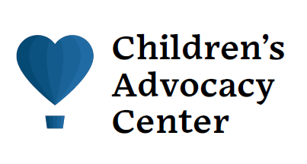

Initial Appointment

Your child or a child in your care has been scheduled for an appointment at the Children’s Advocacy Center of Portage County (CAC). The CAC is located within the University Hospitals Portage Medical Center at 6847 North Chestnut Street in Ravenna. Please enter through the main lobby doors and let the lobby desk staff know you are here for an appointment with the Children’s Advocacy Center. Here is some additional information to help you in the time before your appointment and prepare you for the appointment. Before your appointment, please feel free to call the CAC with any additional questions, concerns, or if you are in need of support at 330-297-8838.

- It’s important to let your child/teen know about the CAC appointment. Assure them they will have a safe place to tell the truth with a caring nurse and advocate. Try not to question your child/teen or discuss details that may be traumatic. Some helpful things to say are: I am here for you, I love you, I believe you.

- The length of time for the appointment is between 2-3 hours.

- The CAC nurse practitioner will meet with caregivers/parents to gather medical information, answer questions, and discuss next steps

- The CAC nurse practitioner will talk with your child/teen in an interview room. The CAC nurse practitioner has special forensic interviewer training to work with children/teens.

- The CAC nurse practitioner will explain the option for a physical exam and/or lab testing with your child/teen. The physical exam is not an internal exam. If they are not comfortable with any part of the physical exam, they have the right to refuse the exam. They can consent to one part of the exam and not another part. Nothing is forced upon a child/teen at the CAC.

- A trained CAC advocate will talk with caregivers/parents and children/teens to provide support, help answer questions, and help with any concerns. The advocate will also provide information on what to expect after the CAC appointment and will be your support throughout the entire process. You will also be given a resource and referral folder with helpful information to take home.

- Finally, the nurse practitioner, advocates, and family meet together to ensure everyone is aware of next steps, follow-up information, any final questions, and family has an opportunity to complete a survey regarding CAC services.

